Code 1 - Virtual
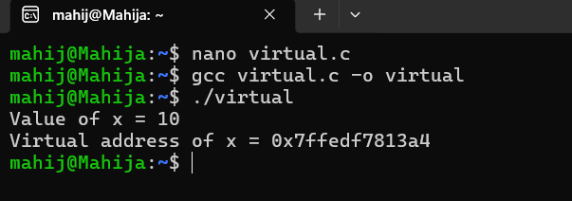

Code 2 - Address Space
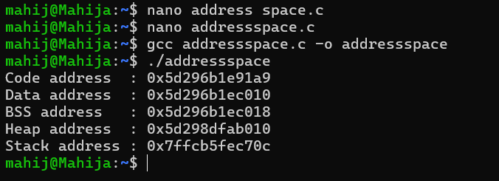

Code 3 - Demand Paging
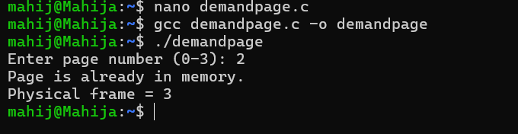

Code 4 - Address Translation
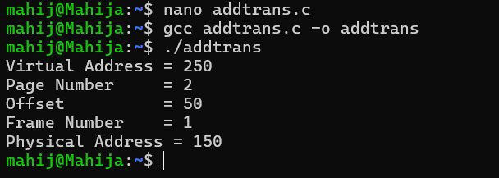

Code 5 - Memory
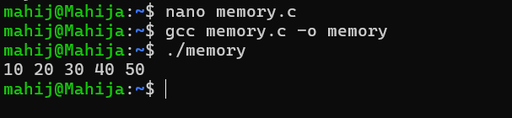

Code 6 - Access Memory
